What is a labyrinth?
Although the presence of the labyrinth in Christian churches may be new to many, it is a sacred symbol that can be traced back 3,000 years to ancient Greece, and many other ancient cultures as well. Historically, Christian pilgrims walked the labyrinth as a symbolic journey to Jerusalem. Labyrinths were designed in my forms, the earliest being in linear patterns. By the ninth century, however, a more circuitous design appeared, making the path less obvious and more representative of our own journeys.
The labyrinth at Trinity Lutheran is a copy of the most well-known labyrinth of the Middle Ages, found in the Cathedral of Notre Dame de Chartres. At the center there is a rose-shaped area – a place to stop, pray, meditate, and receive what is offered. Trinity also has a canvas labyrinth to be used indoors. The Trinity labyrinth has been incorporated into a Prayer Garden setting which is used for worship, remembrance, fellowship, and prayerful meditation.
The labyrinth as a spiritual tool
Our lives are a journey, a sacred journey, where we encounter joy, sorrow, growth, defeat, grief, celebration and all the other experiences that challenge and transform our understanding of life. Symbolic of this journey, the labyrinth functions as a meditation tool, a prayer tool, to help us focus and encounter the presence of the sacred in our changing lives. Unlike a maze, a labyrinth has no dead ends, and there are no tricks or puzzles to be solved. The path in ... is the path out ... and as such represents the wholeness of our lives. Therefore, walking the labyrinth is an invitation to use the gifts of creativity, imagination, and receptiveness.
The journey can take us inward to our center and then back out into the world with new insights into ourselves and God’s presence in our lives. It is not magic, however, and like any spiritual tool sometimes we receive guidance, sometimes new questions, and other times all we hear is silence.
How do I walk the labyrinth?
There is no “correct” way to walk the labyrinth. It can be walked slowly, it can be danced. As you become more comfortable with this tool, you may find yourself experimenting with different approaches. Listed below are some suggested ways that have been fruitful for others. They provide a good place to begin.
A few ways to walk the labyrinth
Walking for Inward Peace – Before entering the labyrinth, recognize the relationships or situations that are disturbing your sense of wellness. As you walk, be very aware of your body, your breathing. On the way to the center, imagine each exhaled breath taking away the stress of every situation. At the center, open your heart and mind to receive what is offered. Leaving the labyrinth, imagine each inhaled breath giving strength and courage to change what you can and to let go of the rest.
Enter with a Question – Take a few moments to center yourself and identify what the questions are in your life or where your attention is focused at the moment: a new job, marriage, grief, parenthood, the need for new direction, a troubled relationship, etc. Walk the labyrinth seeking new insights or guidance.
The Three-fold Mystical Path – The journey to the center is a time of cleansing. It is a time to let go of all that burdens you today. You may feel joy, tears, peace ... receive whatever you experience ... with an open heart and an open mind. The time at the center is called illumination. Again, with an open heart and mind, pray and meditate and receive whatever is given. Stay until you are ready to leave; you’ll know when it’s time. The journey out of the labyrinth is the union stage. Integrate any insights you have received into your life, knowing God is with you.
A Prayer Walk – Use it at any time to pray for someone or give thanks. Pray using a mantra or breath prayer or a favorite scripture verse or line from a hymn. Some examples:
- Jesus, Son of God, have mercy on me
- The Lord is my shepherd
- Gracious God, heal my broken spirit
- God of grace, God of glory, fill me with your presence
- Keep watch, dear Lord with _______
- I come with joy to meet my Lord
- Serenity Prayer: “God grant me the serenity to accept the things I cannot change; courage to change the things I can; and wisdom to know the difference”
If another verse or phrase comes while walking, receive and use it.
Looking in the Mirror – While walking the labyrinth with others, try to perceive a part of yourself in each person. Open your heart to all those around you. Pray for the well-being of each person. Open your heart to yourself. Pray for yourself.
Beginning your walk
When you are ready, enter the labyrinth at the opening beyond the concrete. Walk at your own pace.
Remember, the path in ... is the path out ... a two-way street where you may meet others as they leave and travel at a different pace. Carefully step around one another and continue your journey. Relax and try not to be self-conscious. Your walk may take 20 minutes or over an hour. Again, there is no right or wrong way to walk the labyrinth.
When you are finished, take some time to reflect on your walk. You may find journaling or drawing an aid to your reflection.

A Holy Walk
To walk the labyrinth is to touch God
and let God touch us.
It is a matter of presence and response.
The labyrinth does nothing
to make God more present...
for God is always present.
The labyrinth can make us aware of the presence
of God in our lives.
So be silent.
Walk.
Listen.
Wonder.
Receive God’s gifts.
Go in peace on your journey.
-Author Unknown

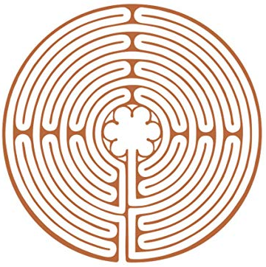

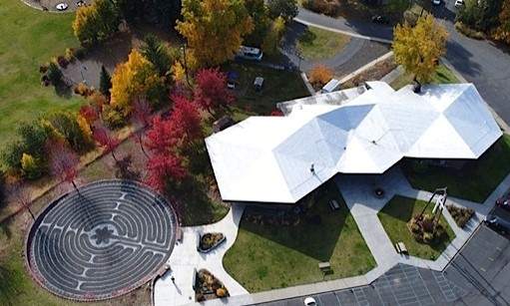

Trinity Lutheran
1300 Lybecker Road,
Pullman, WA 99163
509-332-1985
www.trinitypullman.org

This brochure modeled on one from Cathedral of St. John, Spokane, WA

The Labyrinth
A Holy Walk

A ministry to the people of Trinity Lutheran and the Pullman Community

